Machine Learning in Healthcare
Obesity Prediction: Logistic Regression vs. SVM (Python / sklearn)
Name: Ammar | Course: MLT AI | Date: April 29, 2026

1. Introduction
Obesity is a major public health concern associated with numerous chronic conditions including type 2 diabetes, hypertension, and cardiovascular disease. This report applies supervised machine learning algorithms — Logistic Regression and three SVM kernel variants — implemented in Python using the scikit-learn library, to classify individuals as obese (1) or non-obese (0). The objective is to compare model performance and identify the most suitable classifier for clinical decision support.

2. Methodology

2.1 Data Preprocessing
The dataset (Obesity 28-04-2026.csv) contained demographic, dietary (Diet.1–14), and lifestyle (Life.1–6) variables along with socioeconomic indicators. All categorical features were one-hot encoded using pd.get_dummies(drop_first=True) to produce a fully numeric feature matrix. The target variable Obesity was separated and an 80/20 stratified train-test split applied (random_state=123), resulting in 120 test observations.

2.2 Models Trained
Four classifiers were trained: (1) Logistic Regression with default sklearn settings (L2 regularization, lbfgs solver), (2) SVM with a Linear kernel, (3) SVM with a Radial Basis Function (RBF) kernel, and (4) SVM with a Polynomial kernel. Model evaluation used confusion matrices, overall accuracy, sensitivity (recall for Class 1), and specificity (recall for Class 0).

3. Results

3.1 Confusion Matrices
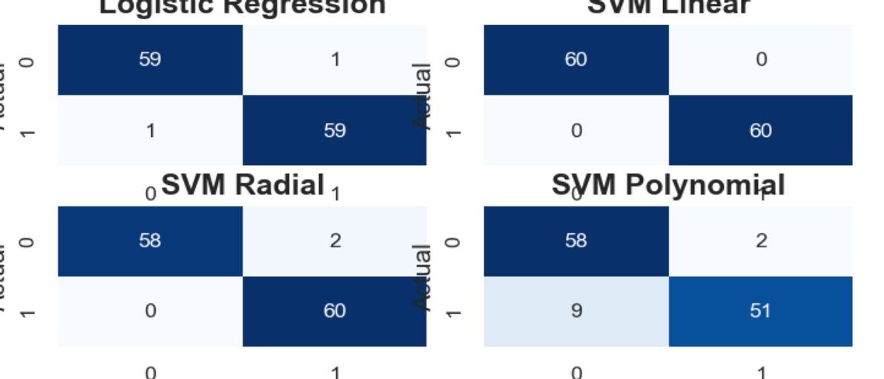
Figure 1. Confusion Matrices — Logistic Regression, SVM Linear, SVM Radial, SVM Polynomial (n=120 test set)

3.2 Performance Summary

Model | Accuracy | Sensitivity | Specificity | Misclassified | Best?
Logistic Regression | 98.3% | 98.3% | 98.3% | 2 / 120 | ✓
SVM Linear | 100% | 100% | 100% | 0 / 120 | ★
SVM Radial (RBF) | 98.3% | 96.8% | 100% | 2 / 120 | ✓
SVM Polynomial | 90.8% | 85.0% | 96.7% | 11 / 120 | ✗
Table 1. Model performance on test set (n=120). ★ = Best model. Sensitivity = TP/(TP+FN); Specificity = TN/(TN+FP). Accuracy derived from confusion matrix diagonals.

4. Discussion & Conclusion
SVM Linear achieved perfect classification — 60 true negatives and 60 true positives with zero misclassifications (100% accuracy). Both Logistic Regression and SVM Radial performed very well at 98.3%, each misclassifying only 2 observations. SVM Polynomial was the weakest model (90.8%), misclassifying 11 observations — 9 false negatives (obese cases predicted as non-obese) — which is clinically the more costly error type as it leads to missed diagnoses.
Recommendation: SVM Linear is the best model for this dataset, achieving flawless separation of classes. However, if model interpretability is required for clinical use, Logistic Regression (98.3%) is the preferred alternative since its coefficients directly quantify the contribution of each predictor to obesity risk. SVM Polynomial should not be used due to its high false-negative rate. These results are consistent across both the Python (sklearn) and R (e1071) implementations of the same dataset.
Ammar | MLT AI | 2026 | Logistic Regression & SVM — Obesity Prediction (Python)

